Non-Disclosure Agreement

- I ____Hoya Wang_______ (the designer, “Discloser”) agrees to keep Designer Avenue’s (the company, “Recipient”) platform and business idea confidential until Designer Avenue officially launches website publically on 31st May 2017
(“Purpose”).
- The company and I agree that” Confidential Information” means all confidential or proprietary information relating to the Purpose that is made available at any time, in any form, directly or indirectly, by me to the company.
- In consideration for me disclosing the Confidential Information to the company, the undertake that the company shall:
- keep the Confidential Information secret and confidential; and
- not use or exploit the Confidential Information in any way except in connection with the Purpose.
- The company agree and acknowledge that damages would not be an adequate remedy for any breach of the terms of this agreement by you.
- This agreement shall be governed by English law under the jurisdiction of the English courts.
[Signature]

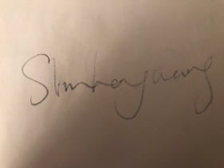

28/05/2017

